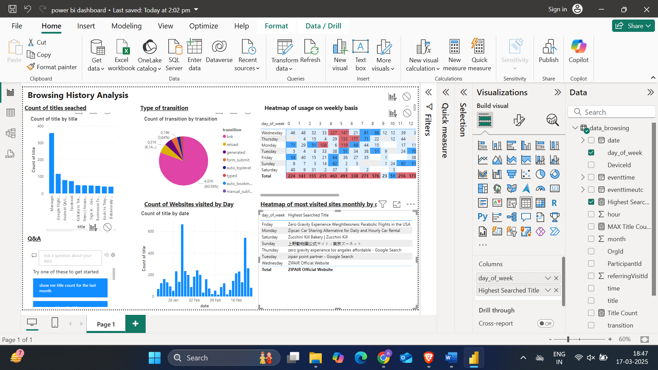

This is the dashboard required based on the dataset provided for the assignment.

Lets go step by step

1. Data Preprocessing::

* Understood the data, tried to analyze the patterns
* Got to know that data is of one user, from one device and over 2 months of browsing data
* Extracted date, time, month and year to get some good insights.
* Removed the rows in which the Title is none.

1. Creating Dashboard::

* Did 5 diff types of plots
* 1st is which Title is searched the most to understand the interests of user.
* 2nd is Transition pie chart which tells us the type of page was opened ie, links, forms etc.
* 3rd is a heatmap of usage of device which tells us frequency of websites visited per hour.
* 4th is count of website per day.
* 5th is name of most visited sites monthly acc to day.

So, this is the whole idea behind making the dashboard, there are still scope of improvement such as using visited_id and referring_visit_id to understand the flowgraph.